**Assignment Week 7 - PostgreSQL Exercises**

Your ID: 2132300593

Your Name: Nguyen Thanh Giang

## Introduction

Welcome to PostgreSQL Exercises! This site was born when I noticed that there's a load of material out there to help people learn about SQL, but not a great deal to make it easy to learn by doing. PGExercises provides a series of questions and explanations built on a single, simple dataset. It's designed for use as a partner to a good book or Postgres' excellent [documentation](https://www.postgresql.org/docs/current/index.html).

Link: <https://pgexercises.com/>

The exercises on this site range from simple select and where clauses, through joins and case statements, and on to aggregations, window functions, and recursive queries. Most people who aren't already pros should find something to test themselves with.

For an introduction to the dataset, go to [Getting Started](https://pgexercises.com/gettingstarted.html), then select an exercise category from the menu and go!

It's pretty simple to get going with the exercises: all you have to do is [open the exercises](https://pgexercises.com/questions/basic/), take a look at the questions, and try to answer them!

The dataset for these exercises is for a newly created country club, with a set of members, facilities such as tennis courts, and booking history for those facilities. Amongst other things, the club wants to understand how they can use their information to analyse facility usage/demand. **Please note:** this dataset is designed purely for supporting an interesting array of exercises, and the database schema is flawed in several aspects - please don't take it as an example of good design.

<https://pgexercises.com/gettingstarted.html>

### Important notes:

Try do not to show Answer and Discussion before you complete it. 😊



## Part 1: Simple SQL Queries Begin!

This category deals with the basics of SQL. It covers select and where clauses, case expressions, unions, and a few other odds and ends. If you're already educated in SQL you will probably find these exercises fairly easy. If not, you should find them a good point to start learning for the more difficult categories ahead!

Link to practice: <https://pgexercises.com/questions/basic/>

Read the instructions and complete 12 questions below:

1. Retrieve everything from a table
2. Retrieve specific columns from a table
3. Control which rows are retrieved
4. Control which rows are retrieved - part 2
5. Basic string searches
6. Matching against multiple possible values
7. Classify results into buckets
8. Working with dates
9. Removing duplicates, and ordering results
10. Combining results from multiple queries
11. Simple aggregation
12. More aggregation

**Example:**

## Part 2: Joins and Subqueries

This category deals primarily with a foundational concept in relational database systems: joining. Joining allows you to combine related information from multiple tables to answer a question. This isn't just beneficial for ease of querying: a lack of join capability encourages denormalisation of data, which increases the complexity of keeping your data internally consistent.

This topic covers inner, outer, and self joins, as well as spending a little time on subqueries (queries within queries)

Link to practice: <https://pgexercises.com/questions/joins/>

Read the instructions and complete the 8 questions below:

1. Retrieve the start times of members' bookings
2. Work out the start times of bookings for tennis courts
3. Produce a list of all members who have recommended another member
4. Produce a list of all members, along with their recommender
5. Produce a list of all members who have used a tennis court
6. Produce a list of costly bookings
7. Produce a list of all members, along with their recommender, using no joins.
8. Produce a list of costly bookings, using a subquery

## Your Answer:

The results (SQL script and report) must be submitted to your GitHub account and share link here

Link: [View 1 · PGEXERCISES BASIC & JOINS AND SUBQUERRIES](https://github.com/users/aiGyuH1612/projects/1/views/1)

Below can as sample report:

## Part 1: Simple SQL Queries Begin!

1. Retrieve everything from a table

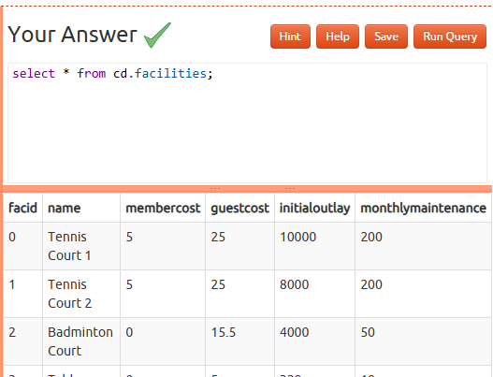

1. Work out the start times of bookings for tennis courts

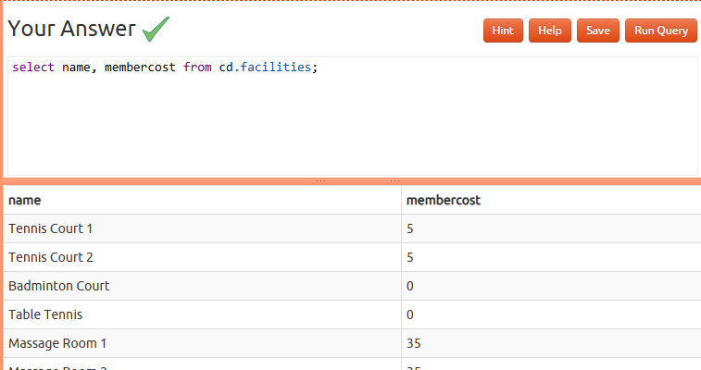

1. Produce a list of all members who have recommended another member

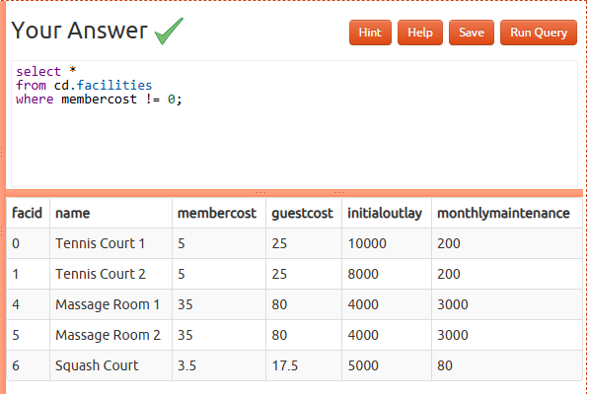

1. Produce a list of all members, along with their recommender

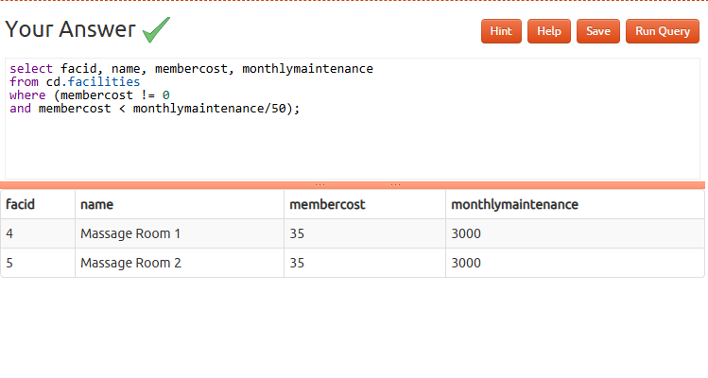

1. Produce a list of all members who have used a tennis court

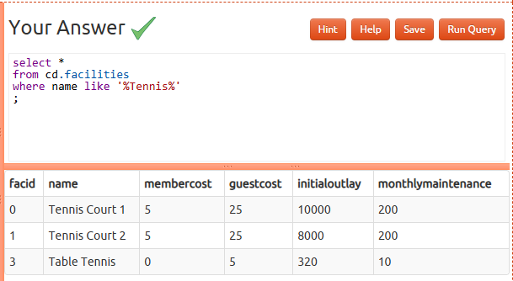

1. Produce a list of costly bookings

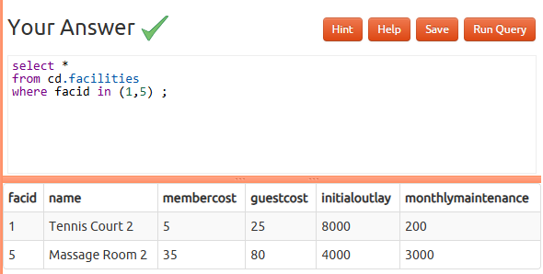

1. Produce a list of all members, along with their recommender, using no joins.

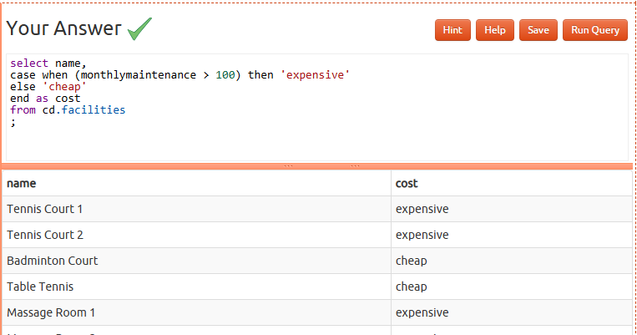

1. Produce a list of costly bookings, using a subquery

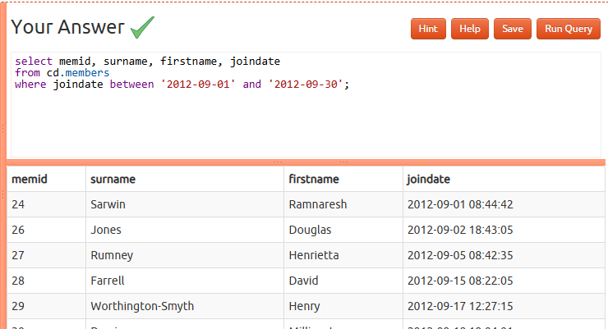

## Part 2: Joins and Subqueries

1. Retrieve the start times of members' bookings

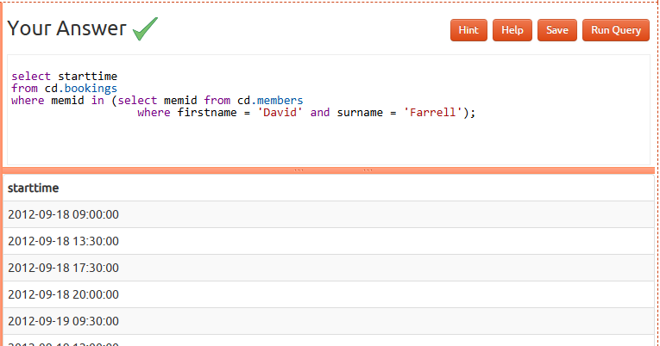

1. Work out the start times of bookings for tennis courts

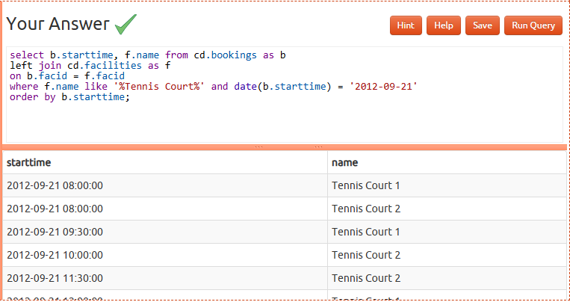

1. Produce a list of all members who have recommended another member

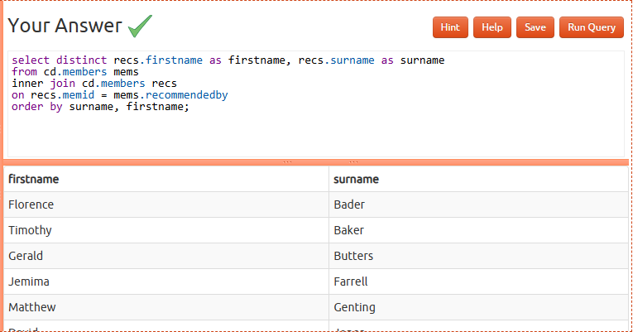

1. Produce a list of all members, along with their recommender

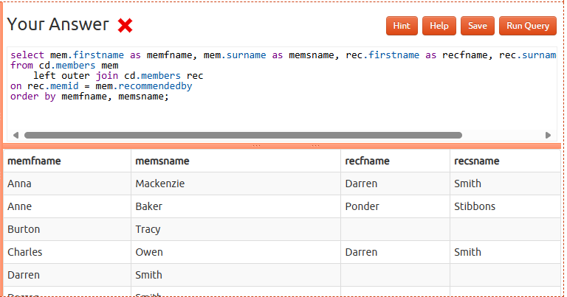

1. Produce a list of all members who have used a tennis court

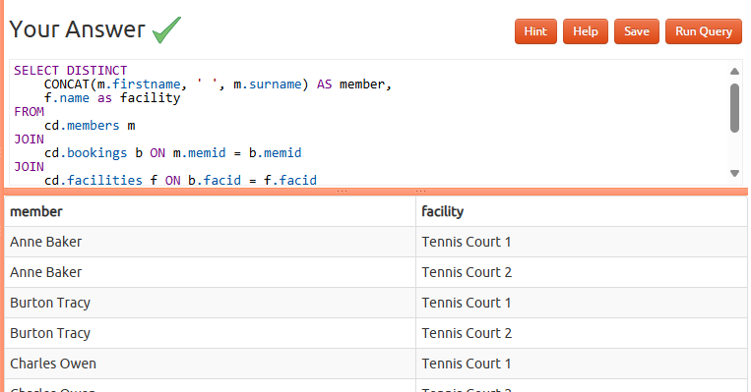

1. Produce a list of costly bookings

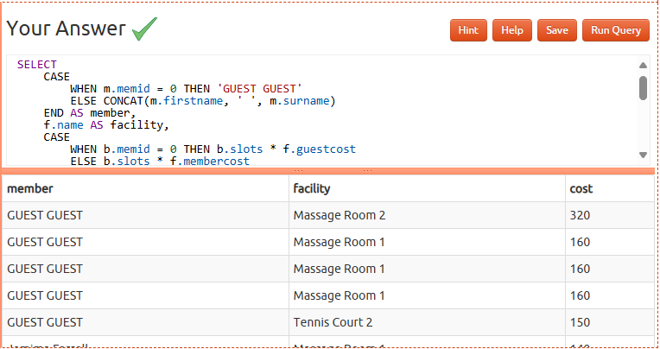

1. Produce a list of all members, along with their recommender, using no joins.

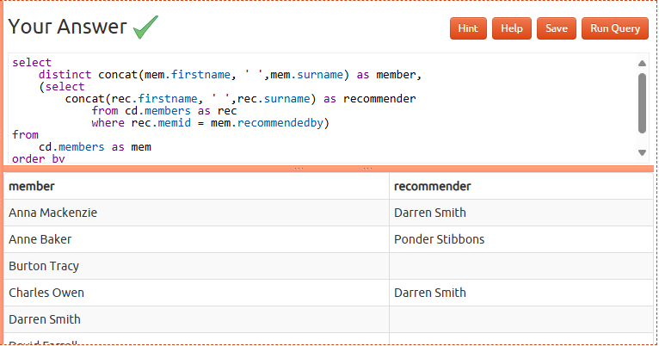

1. Produce a list of costly bookings, using a subquery

